Daniel DeCarlo

Box # 107

Cairn University School of Business

CIS122 Essentials of Networking

Project # 11

Project objective:

The purpose of this project is to monitor what kind of data/packets go through our network. Along with this project we can see where the data is coming from and knowing where the data is coming from we can determine if it is a safe IP address. Monitoring the network traffic can help see if there are potential attacks that can exploit our network.

Equipment used:

|  |  |  |  |  |
| --- | --- | --- | --- | --- |
| Equipment Description | Vendor | Vendor Item # | Retail price | Actual price (if known) |
| Wire Shark (3.0.1) Windows 64-bit | Wireshark | Stable Release 3.0.1 | Free Download |  |
|  |  |  |  |  |
|  |  |  |  |  |

Detailed list of software and operating platforms used, including version numbers and licensing requirements:

* Wire Shark Stable Release 3.0.1 Windows 64-bit

Network diagram/Configurations:

Step 1) Go to <https://www.wireshark.org/#download> and download the Windows version of wireshark.

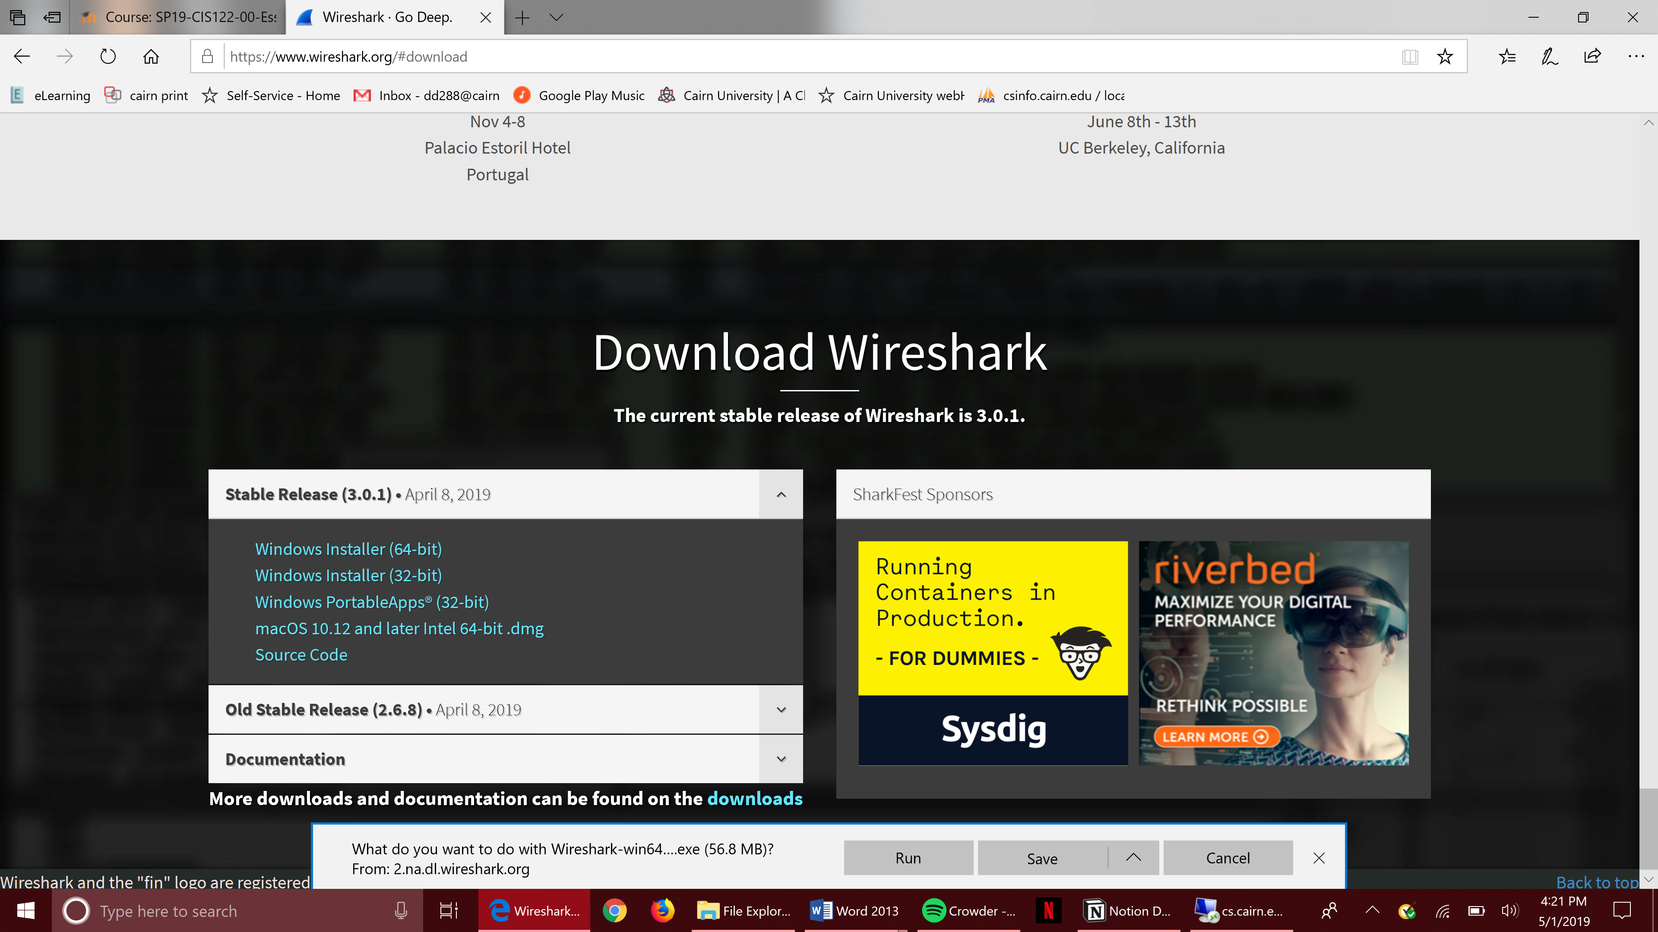

2) A prompt will appear asking to make changes. Click Yes.

3) Follow the installation Wizard

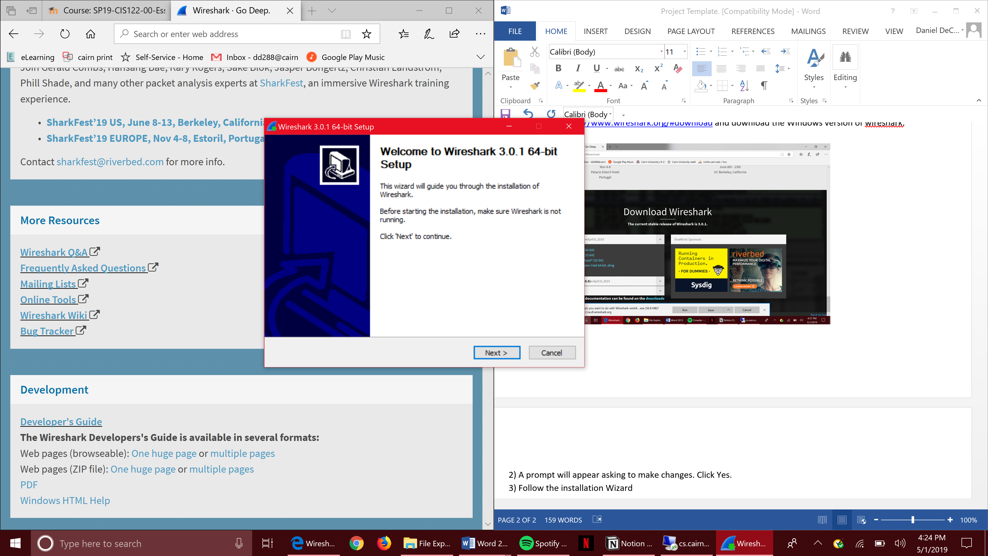

4) Complete the Wizard set up and install wire shark. Then when it is done installing you will see different options on the different monitoring you can do over your networks.

5) When choosing a specific network like “Ethernet” a list of a bunch of numbers will appear. These numbers are the different signals going through the network and any suspicious IP numbers listed mark it and find which device it’s communicating with.

6) There are filter options with this software so you can filter out IP addresses you don’t want to see. Find out more information on https://www.wireshark.org/#download.